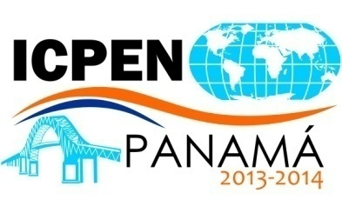

INTERNATIONAL CONSUMER PROTECTION AND ENFORCEMENT NETWORK (ICPEN)

Panama City, Panama

May 20, 21, 22 and 23, 2014

PRACTICAL INFORMATION GUIDE FOR DELEGATES

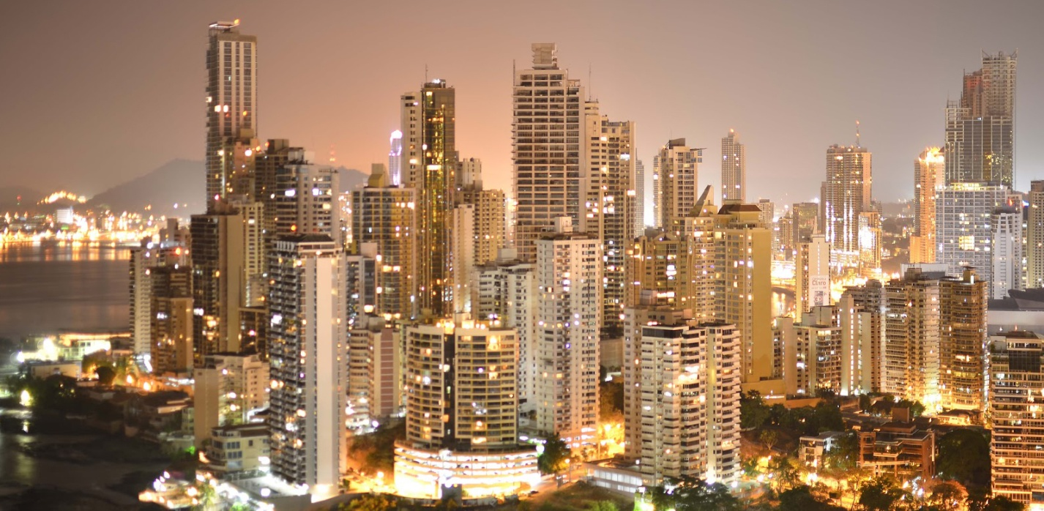

“Enhancing Consumer Protection in a Global Economy”

The Republic of Panama is a country located on the southwest of Central America, bounded on the North with the Caribbean Sea, on the South with the Pacific Ocean, on the East with the Republic of Colombia and on the West with the Republic of Costa Rica.

Its conditions of a country of transit make it a cultural meeting point from around the world. The country is the geographical stage of the Panama Canal, designed to facilitate communication between the Atlantic and the Pacific Oceans which has influenced significantly world commerce. For its geographical position, currently offers a wide platform of maritime, commercial, real estate and financial services, among them, the Colon Free Zone.

Description of the Event

The ICPEN Conference will take place in the Sheraton Hotel and Convention Center, located in Panama City, during May 20, 21, 22 and 23, 2014.

Register for the ICPEN

Participants must make their registration in the following link: https://es.surveymonkey.com/s/panamapresidency

Early Registration: on May 20, 2014, in the Sheraton Hotel and Convention Center, Salon Azuero, from 16:30 to 18:30, participants can register and will be given their accreditations for the ICPEN Conference.

Registration: May 21, 2014, from 7:00 to 9:00, Gran Salon of Sheraton Hotel and Convention Center.

Contact Persons of the Consumer Protection and Competition Defense Authority (ACODECO)

Pedro M. Meilán N. – General Administrator of ACODECO.
Ph: (507) 510-1359 Mobile: (507) 6671- 5616 Fax: (507) 510-1401
Email: pmeilan@acodeco.gob.pa

Lupe Cedeño – Administration Office – ACODECO
Ph: (507) 510-1359 Mobile: (507) 6949- 1731 Fax: (507) 510-1401
Email: dgcedeno@acodeco.gob.pa; lupec1127@gmail.com;

Elias Elias Cabrera- Consumer Protection National Director
Ph: (507) 510-1372 Mobile: (507) 6672-0497 Fax: (507) 510-1401
Email: eelias@acodeco.gob.pa; eliaseliascabrera@gmail.com

We welcome comments, questions, panel suggestions, speaker suggestions or inquiries to the following individuals (please send it to all email addresses of the contact person):

1.-Deon Woods Bell, Office of International Affairs, U.S. Federal trade Commission
Ph: (202) 326-3307 (tel)
Email: dwoodsbell@ftc.gov

2.-Elias Elias Cabrera- Consumer Protection National Director
Ph: (507) 510-1372 Mobile: (507) 6672-0497 Fax: (507) 510-1401
Email: eelias@acodeco.gob.pa; eliaseliascabrera@gmail.com

With a copy to:
3.-Lupe Cedeno – Administration Office – ACODECO
Ph: (507) 510-1359 Mobile: (507) 6949- 1731 Fax: (507) 510-1401
Email: dgcedeno@acodeco.gob.pa; lupec1127@gmail.com

4.-Sofia Rigas – International Affairs Office - ACODECO
Ph: (507) 510-1363 Ext. 268
Email: srigas@acodeco.gob.pa; sofiarigas@gmail.com

Objective
- To Generate and to exchange information and intelligence on consumer protection issues.
- To share the best practices in legislative topics and consumer protection enforcement.
- To take actions to combat cross-border violations of consumer protection laws.
- To facilitate effective cross-border remedies.
- To identify and to promote measures for consumer protection enforcement.
- To promote and to encourage greater participation and cooperation with other consumer protection organizations.

Participants Profile

Consumer Protection Authorities and Agencies, their officials and related organizations involved in consumer protection topics.

Accreditation

ACODECO will offer all participating members, partners and observers from official delegations, credentials for the ICPEN Conference.

Computer Center

Participants will have access to computers with internet, printer, scanner and copier machine.

Food

Lunch will be offered by ACODECO at the Sheraton Hotel & Convention Center.

Information of the hotels near to the event place

The Sheraton Hotel and Convention Center is located in a central area of Panama City. Its precise address is in Via Israel and 77 Street, San Francisco, Panama City, Panama.

Located just 15 minutes from Tocumen International Airport and 10 minutes from banking and commercial district.

Following, we submit to your consideration a list of hotels that may be of interest for their proximity to the Sheraton Panama Hotel and Convention Center:

Hotel | Contact Person | Single Room | Double Room | % Tax | Details
Hotel where ICPEN will take place:  Sheraton Panama Hotel & Convention Center  (Via Israel and Calle 77, San Francisco) | Yashira Douglas  Tel. +507 305-5177 | $159.00 | $159.00 | 10% | Deluxe, 1 King bed or 2 Double beds.  Includes: breakfast, access to fitness center and lounge club and in-room  high speed internet access.
Aloft Panama  (Via Israel and Calle 76, San Francisco) | Yashira Douglas  Tel. +507 305-5177 | $109.00 | $109.00 | 10% | 1 King size bed or 2 Queen beds.  Includes: breakfast and high speed internet access. No room service, no bellhop.
Courtyard by Marriott (Via Israel Multiplaza Pacific Mall) | Laura Rangel  Tel. +507 301-0101 | $189.00 | $189.00 | 10% | 1 King or 2 Double beds.  Includes: buffet breakfast, use of business centre and community desk.
Radisson Decapolis Hotel (Avenida Balboa, Multicentro) | Stefany Markland  Tel. +507 215-5000 | $120.00 | $120.00 | included | Single or double room with 1 King bed or 2 Double.  Includes: buffet breakfast & Wifi.
Hard Rock Hotel (Avenida Balboa, Multicentro) | Stefany Markland  Tel. +507 215-5000 | $135.00 | $135.00 | included | King size beds or Doubles.  Includes: buffet breakfast, internet.
Plaza Paitilla Inn | Viviana Pardo Tel. +507 208-0600 | $85.00 | $95.00 | 10% | Single room with 1 King bed and Double room with 2 double beds. Includes: buffet breakfast and WiFi.
Panama Marriott Hotel (Calle 52 y Ricardo Arias, Area Bancaria, Bella Vista) | Cesar Guardia Tel. +507 210-9100 | $150.00 | $150.00 | 10% | Premium Deluxe 1 King or 2 Double Includes: buffet breakfast, free parking, free internet at lobby.  In-room internet for a fee.
The Saba Hotel (Via Argentina) | Tel. +507 201-6100 | $78.00 | $78.00 | 10% | Single room with 1 double bed & Double room with 1 double bed and 1 twin bed.  Includes: WiFi, business center, buffet breakfast and local calls. Halal Occupation & Food.

- We recommend making reservations as soon as possible to prevent prices changes.

PANAMA
GENERAL INTEREST INFORMATION

Official Currency

The official currency is the Balboa, however the US Dollar (USD $) is widely used nationwide.

Weather

Panama City only has two seasons: dry and rainy seasons. May is on rainy season, however still in the transition period between both seasons, therefore scattered showers may be expected during the month.

Entry Requirements

As follows, we have: A- List of countries that require an Authorized Entry Visa, which have to be submitted and processed with two (2) months anticipation; B- List of countries that require a Stamped Visa; and C- List of countries that do not require an Entry Visa for the Republic of Panama:

- COUNTRIES THAT REQUIRE AN AUTHORIZED ENTRY VISA

The participants from countries that require an authorization to obtain an authorized entry visa, will have to fill out a form for Visa Request from this link: http://www.migracion.gob.pa/images/FORMULARIO%201.1/FORMULARIO%20DE%20VISAS%20DE%20TURISTAS%20PARA%20CONVENCIONES%20INTERNACIONALES.pdf and send it to us fully completed with copy of his/her passport to: panama@acodeco.gob.pa

All documents will be then send to the National Immigration Service for processing, which will decide the granting of the Entry Visa or ask for new requirements.

Afghanistan | Chad | Iran | Morocco | Democratic People’s Rep. of Korea | Turkmenistan
Albania | Djibouti | Iraq | Mauritania | Rwanda | Uganda
Algeria | Egypt | Jordan | Mozambique | Senegal | Uzbekistan
Azerbaijan | Eritrea | Kazakhstan |  | Sierra Leone | Yemen
Bahrain | Ethiopia |  | Nepal | Syria | Zambia
Bangladesh | Gambia | Kyrgystan | Niger | Somalia
Benín | Guinea | Laos | Nigeria | Sri Lanka
Burkina Faso | Guinea Bissau | Lesotho | Oman | Sudan
Burma | Equatorial Guinea | Lebanon | Pakistan | Suriname
Burundi | Haiti | Liberia | Palestine | Tanzania
Côte d’ Ivoire | India | Libya | Dem. Rep. of Congo | Tajikistan
Cuba | Indonesia | Mali | People’s Rep. of China | Tunisia

For more information on the required documents for entry to our country, please access http://www.migracion.gob.pa. and also, verify the list of embassies and consulates in Panama on the web at http://www.mire.gob.pa .

- COUNTRIES THAT REQUIRE STAMPED VISA

Participants from countries that require a Stamped Visa must approach the nearest Panamanian Consulate in their country. There, the necessary information and documents will be provided to process their visas.

Cameroon
Russian Federation
Ghana
Malawi
Central African Republic
Rep.of the Congo
Dominican Republic
Swaziland
Togo
Zimbabwe
Philippines

- COUNTRIES THAT DO NOT REQUIRE VISA.

The following countries do not require an entry visa to Panama:

Germany | Brunei | Estonia |  | Kiribati | Norway | Sao Tomé y Príncipe
Andorra | Bulgaria |  | Fiji | Kuwait | New Zealand | Serbia
Angola | Cape Verde |  | Finland | Latvia | Netherlands | Seychelles
Antigua and Barbuda | Cambodia |  | France | Liechtenstein | Palau | Singapore
Saudi Arabia | Canada |  | Gabon | Lithuania | Papua New Guinea | St. Lucia
Argentina | Chile |  | Georgia | Luxembourg | Paraguay | South Africa
Armenia | Cyprus |  | Grenada | Macedonia | Peru | Sweden
Australia | Colombia |  | Guatemala | Madagascar | Poland | Switzerland
Austria | Rep.of South Korea |  | Guyana | Malaysia | Portugal | Thailand
Bahamas | Costa Rica |  | Honduras | Maldives | Qatar | Taiwan
Barbados | Croatia |  | Hungary | Malta | United Kingdom | Tonga
Belgium | Denmark |  | Ireland | Mexico | Czech Rep. | Trinidad and Tobago
Belize | Dominica |  | Iceland | Micronesia | Hellenic Rep. | Turkey
Bhutan | Ecuador |  | Comoro Islands | Moldova | Sahrawi Rep. | Tuvalu
Belarus | El Salvador |  | Marshall Island | Monaco | Romania | Ukraine
BNO (British National Overseas) | United Arab Emirates |  | Solomon Island | Mongolia | Samoa | Uruguay
Bolivia | Slovak Rep. |  | Israel | Montenegro | Saint Kitts & Nevis | Vanuatu
Bosnia – Herzegovina | Slovenia |  | Italy | Namibia | San Marino | Venezuela
Botswana | Spain |  | Jamaica | Nauru | St. Vicente & the Granadines | Vietnam
Comoras | Kenya |  | United States of America | Mauritius | Nicaragua | Japan
Brazil

Taxes

All goods, except food, are subject to a 7% sales tax (named ITBMS). A tourist tax of 10% is included in hotels.

Time Zone

Panama is located in the time zone -5 GMT and has no time changes during the year.

Tips

Usually a 10% tip of total bill in many restaurants, but is not mandatory, unless it is advertised on the menu or in a sign in the restaurant. Before paying a tip, be sure that the place does not include it on the bill.

Vaccines

We suggest to all visitors to find information with the Panamanian Consulate in your country because some countries require the yellow fever vaccine and its proof is required to entry the country.

Communications

Panama has direct international dialing service and also mobile service, fax, telex, cable, radio, television and internet. Our international code is 507.

Electricity

In Panama the AC of 110 volt current is used.

